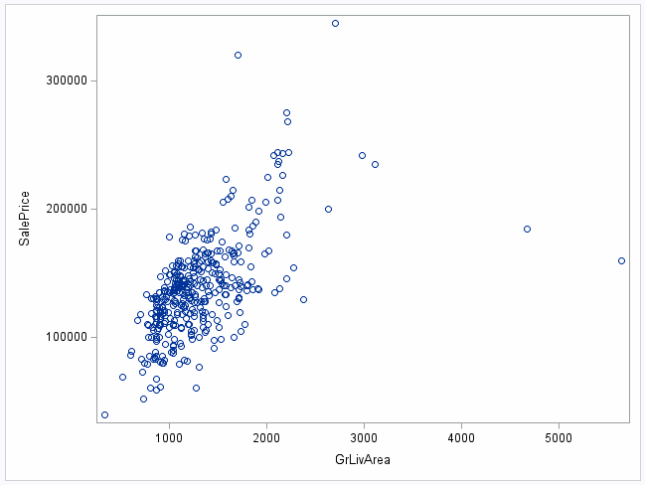

Housing Area vs. sales price. Both axes appear to have a bit of right-skew, so let’s try a log transform.

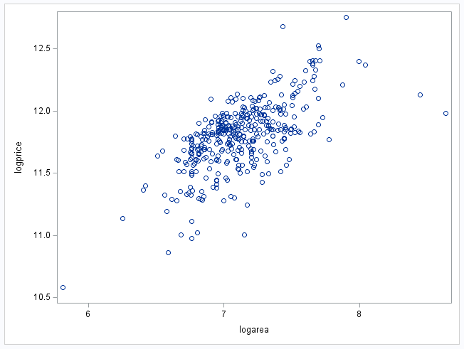

The variance visually looks a bit more evenly spread here, so that shows an improvement.